 | 12.1.28 Editors - Geometry Nodes Editor - Header - Add Menu - Mesh - Read
Table of content
Detailed table of content 1
Add menu - Mesh - Read 3
Edge Angle 3
Edge Neighbours 3
Edge Vertices 3
Edges to Face Group 4
Face Area 4
Face Group Boundaries 5
Face Neighbours 5
Face Sets – Tool Mode 5
Is Face Planar 6
Is Face Smooth 6
Is Edge Smooth 6
Mesh Island 6
Shortest Edge Path 7
Vertex Neighbors 7

Detailed table of content
Detailed table of content
Detailed table of content 1
Add menu - Mesh - Read 3
Edge Angle 3
Outputs 3
Unsigned Angle 3
Signed Angle 3
Edge Neighbours 3
Outputs 3
Face Count 3
Edge Vertices 3
Outputs 4
Vertex Index 1 4
Vertex Index 2 4
Position 1 4
Position 2 4
Edges to Face Group 4
Inuputs 4
Boundary Edges 4
Outputs 4
Face Group ID 4
Face Area 4
Outputs 4
Area 4
Face Group Boundaries 5
Inputs 5
Face Set 5
Outputs 5
Boundary Edges 5
Face Count 5
Face Neighbours 5
Outputs 5
Vertex Count 5
Face Count 5
Face Sets – Tool Mode 5
Outputs 5
Face Set 5
Exists 5
Is Face Planar 6
Inputs 6
Threshold 6
Outputs 6
Planar 6
Is Face Smooth 6
Outputs 6
Smooth 6
Is Edge Smooth 6
Outputs 6
Smooth 6
Mesh Island 6
Outputs 6
Index 6
Shortest Edge Path 7
Input 7
End Vertex 7
Edge Cost 7
Outputs 7
Next Vertex Index 7
Total Cost 7
Vertex Neighbors 7
Outputs 7
Vertex Count 7
Face Count 7

Add menu - Mesh - Read
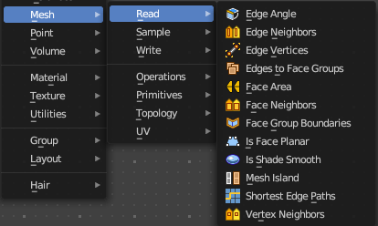
Nodes to modify the mesh geometry.

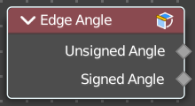
Edge Angle
Calculates the angle in radians between two faces that meet at an edge. Without two faces on the edge, the angle will be 0.

Outputs

Unsigned Angle
The unsigned output angle. The shortest angle will be picked.

Signed Angle
The signed angle between the two faces, where Convex angles are positive and Concave angles are negative. This calculation is slower than the unsigned angle.

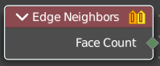
Edge Neighbours
Outputs the number of faces connected to each edge.

Outputs

Face Count
The number of faces.

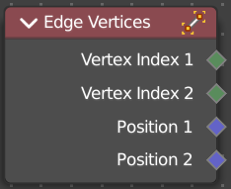
Edge Vertices
Outputs the index and position of the two vertices that defines an edge. Index outputs an integer. Position a vector.

Outputs

Vertex Index 1
The index of the first vertice.

Vertex Index 2
The index of the second vertice.

Position 1
The position of the first vertice.

Position 2
The position of the second vertice.

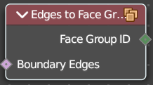
Edges to Face Group
Group Faces into regions, surrounded by the selected boundary edges.

Inuputs

Boundary Edges
The input edges.

Outputs

Face Group ID
The output face group.

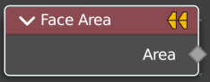
Face Area
Gives each face area a unique id. Which can be used in a capture attribute for example, to create instances of other geometry to this now unique face areas.

Outputs

Area
The face area output.

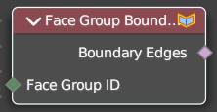
Face Group Boundaries
Find edges on the boundaries between face sets

Inputs

Face Set
The input face sets to calculate the boundaries from.

Outputs

Boundary Edges
The edges that lies on the boundaries between the different face sets

Face Count
The face count for the face neighbors.

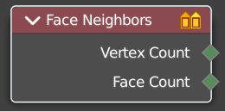
Face Neighbours
Outputs the number of vertices or faces connected to each face.

Outputs

Vertex Count
The vertex count for the face neighbors.

Face Count
The face count for the face neighbors.

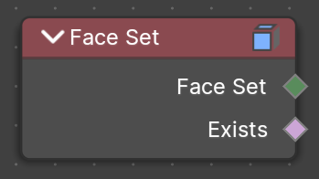
Face Sets – Tool Mode
Get each face’s sculpt face set value to use in the geometry node tree.
This node is only available in the Tool Mode for Node Group Tools assets.

Outputs

Face Set
A face set ID output as integer fields.

Exists
A boolean field output that shows where a face set exists or not.

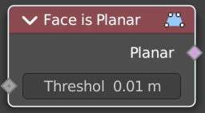
Is Face Planar
Returns true if all of the points of the evaluated face are on the same plane.

Inputs

Threshold
The threshold to consinder the points to be at the same plane.

Outputs

Planar
True if the face is planar.

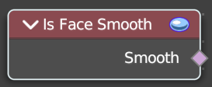
Is Face Smooth
Retreives if the face is shaded smooth.

Outputs

Smooth
Smooth output.

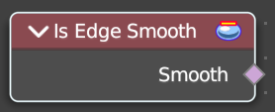
Is Edge Smooth
Retreives if the edge is shaded smooth.

Outputs

Smooth
Smooth output.

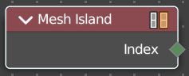
Mesh Island
Outputs a separate index for each mesh island. The indices are based on the order of the lowest-numbered vertex in each island.

Outputs

Index
The index output.

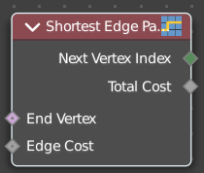
Shortest Edge Path
Calculates the shortest path from multiple start points.

Input

End Vertex
The last point of the path.

Edge Cost
The amount of calculation to find the shortest path.

Outputs

Next Vertex Index
The vertices index of the shortest path.

Total Cost
The calculation amount.

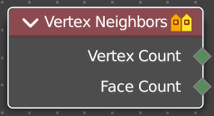
Vertex Neighbors
Outputs the number of vertices or faces connected to each vertex.

Outputs

Vertex Count
The vertex count for the vertex neighbors.

Face Count
The face count for the vertex neighbors.

